**Review Worksheet: *Australopithecus***

**Name: ……………………………………………………………..**

*Do these questions, using your learning resources. Look at the “marks” to give you an idea of the level of detail required in the response (formative only – does not count towards your grade). At the end, mark your work, correct it, and fill in the reflection section. Questions marked * require you to use reasoning, inferring and application of knowledge, or perhaps extra research to get the answer. It won’t be right there in the text.*

1: How long ago did *Australopithecus* live and where could it be found?

(2 marks)

*……………………………………………………………………………………………………………………*

*……………………………………………………………………………………………………………………*

2: Describe the habitat and behaviour of *Australopithecus*\*.

(4 marks)

*…………………………………………………………………………………………………………………….*

*…………………………………………………………………………………………………………………….*

*…………………………………………………………………………………………………………………….*

*……………………………………………………………………………………………………………………*

*……………………………………………………………………………………………………………………*

*…………………………………………………………………………………………………………………….*

3: What aspects of the fossil record show us that *Australopithecus* were bipedal?

(3 marks)

*…………………………………………………………………………………………………………………….*

*……………………………………………………………………………………………………………………*

*……………………………………………………………………………………………………………………*

*……………………………………………………………………………………………………………………*

4: What aspects of Australopithecine dentition shows that they are likely to be human ancestors?

(4 marks)

…………………………………………………………………………………………………………………….

…………………………………………………………………………………………………………………….

…………………………………………………………………………………………………………………….

…………………………………………………………………………………………………………………….

5: What does Australopithecine dentition tell us about their diet?

(2 marks)

*…………………………………………………………………………………………………………………….*

*…………………………………………………………………………………………………………………….*

6: Which of the following skulls is likely to be from an *Australopithecus?* Describe the features that helped you to make the identification. Hint: the other skulls shown are chimp, human and *Paranthropus*.

(4 marks)

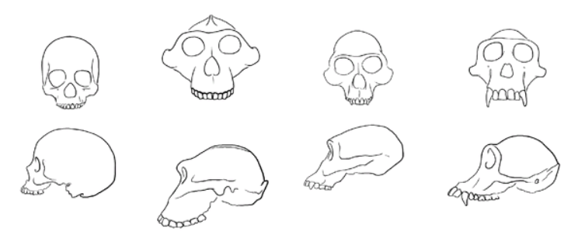

……………………………………………………………………………………………………………………

…………………………………………………………………………………………………………………….

…………………………………………………………………………………………………………………….

…………………………………………………………………………………………………………………….

7: What features of skull and dentition of *Australopithecus africanus* indicate that it is probably more closely related to humans than the earlier *Australopithecus afarensis*?

(2 marks)

*…………………………………………………………………………………………………………………….*

*…………………………………………………………………………………………………………………….*

*…………………………………………………………………………………………………………………….*

*…………………………………………………………………………………………………………………….*

8: You are a paleoanthropologist, working in the Rift Valley of East Africa. A skull is brought to you by one of the University students you supervise. They want to know whether you think it is the skull of an *Australopithecus,* or of *Paranthropus.* List features that would make you think the skull was from *Paranthropus.*

(3 marks)

*…………………………………………………………………………………………………………………….*

*…………………………………………………………………………………………………………………….*

*…………………………………………………………………………………………………………………….*

*…………………………………………………………………………………………………………………….*

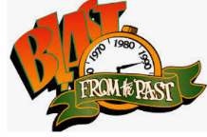

9: a) When an inhibitory neurotransmitter binds to the post-synaptic receptors,

what are the possible effects on the gated channels of the post-synaptic membrane, and what is the resultant effect on the membrane potential and propagation of the action potential?

(6 marks)

*…………………………………………………………………………………………………*

*…………………………………………………………………………………………………*

*…………………………………………………………………………………………………*

*…………………………………………………………………………………………………*

*…………………………………………………………………………………………………*

*…………………………………………………………………………………………………*

*…………………………………………………………………………………………………*

*…………………………………………………………………………………………………*

*…………………………………………………………………………………………………*

*…………………………………………………………………………………………………*

*…………………………………………………………………………………………………*

*…………………………………………………………………………………………………*

b) What does this mean for the speed of transmission?

(1 mark)

*…………………………………………………………………………………………………*

Go back and mark your work using the marking key provided. What score did you get? /31

*I included enough detail in my answers.*



*I was able to find information in the text/powerpoint presentation.*

*I was able to reason and infer where the information wasn’t directly in the text (questions with *).*

*I marked my work and wrote down any answers where I missed marks.*